USER’S

MANUAL

Mr. Salad

**USER’S MANUAL**

**TABLE OF CONTENTS**

1. **GENERAL INFORMATION** 
   1. **System Overview**
   2. **Organization of Manual**
2. **SYSTEM SUMMARY**
   1. **System Configuration**
   2. **User Access Levels**
   3. **Contingencies**
3. **GETTING STARTED** 
   1. **Installation and Logging In**
   2. **System Menu**
   3. **Changing ID** 
      1. **Client**
      2. **User**
   4. **Exit System**
4. **USING THE SYSTEM** 
   1. **Special Instructions for Error Correction**
5. **REPORTING** 
   1. **Sales**
6. **GENERAL INFORMATION**
   1. **System Overview**

Mr. Salad Point of Sales system is an application, which allows for collecting information on clients, users and sales to be stored electronically. The application stores all data in a database created on Access and will be used to create a full-blown Information System in the future.

* 1. **Organization of the Manual**

The user’s manual consists out of: General Information, System Summary, Getting Started, Using the System and Reporting.

The General Information section is a breakdown of what the system we’ve created is going to be used for.

System Summary is used to deliver a general system overview. In the summary, we will outline the software components, user access levels and the behavior of the system in case of errors.

The Getting started section explains how the Mr. Salad point of sales needs to be loaded onto your machine and how it works.

Using the System is a detailed description on how the system functions.

Reporting section is done by generating pdfs on the information the user would like to access and is only accessible by management staff not point of sales users.

1. **System Summary** 
   1. **System Configuration**

Mr. Salad’s Point of Sales system isn’t designed for mobile devices. Runs on any computer with Windows 7 and higher, that is 64 bits’. The system is internet downloadable but can only run when Microsoft.net Framework 4.5.2 is installed. Needs internet access to be able to send the emails. Data is saved on the computer.

* 1. **User Access Levels**

Point of sales staff have access to the client maintenance and point of sales. The management staff have access to entire system which includes client, user and employee maintenance as well as settings.

* 1. **Contingencies**

In case there isn’t internet access we the invoice. All invoices are stored locally on computer to ensure that when internet access is not available invoices can be printed out instead

1. **GETTING STARTED** 
   1. **Installation and Logging In**

System installation version available and can be downloaded at (X) and is an (Y) file. User ID and password are set up by IT team the day of installation. Users are then also shown how to add new users once they have access to the system.

* 1. **Log-In Screen**

The log-in screen is used to access system. Consists of 2 input fields and can select ‘Forget Password’ to get an email notification of a password reset event.

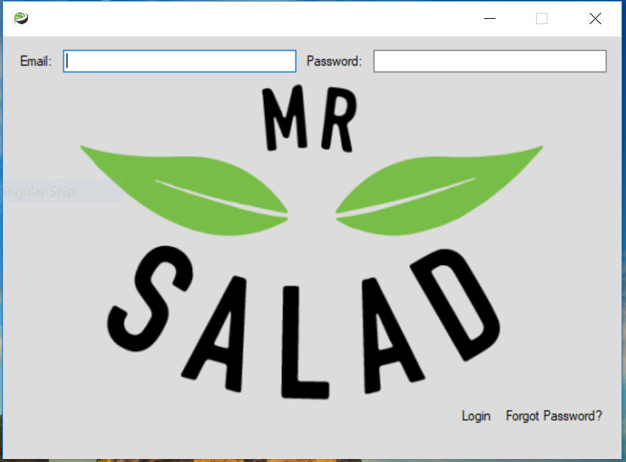

**Figure 1. Log-In Screen**

* + 1. **Dashboard Parent Window**

The Dashboard Parent Window is used to display information which concerns the management team as well as point of sales. There is no input fields and figures are automatically updated when action is performed on the menu strip.

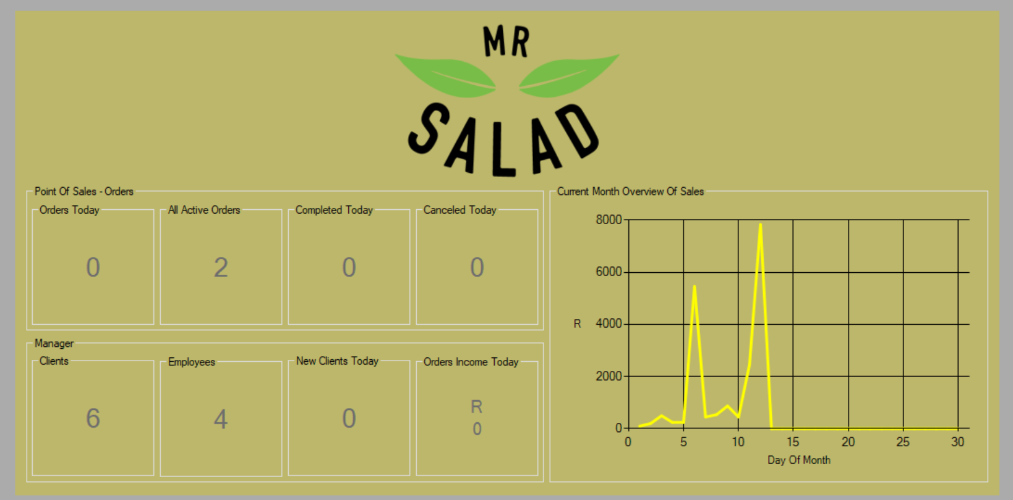

**Figure 2. Dashboard Parent Window**

* + 1. **Add Client Form**

The Add Client Form (Figure 3) is used to add clients to the existing database of previous clients. Consists of 11 input fields containing information on the client being added.

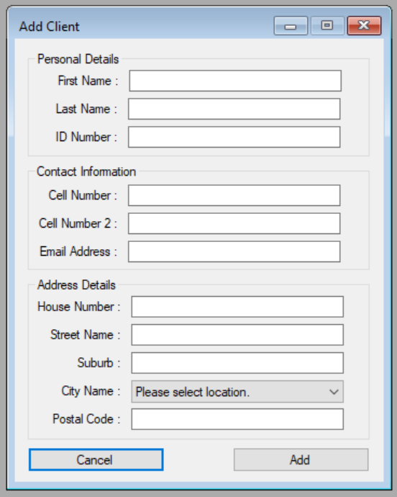

**Figure 3. Add Client Form**

* + 1. **Update Client Form**

The Update Client Form (Figure 4) is used to update existing clients in the database, it consists out of 12 input fields. Of those 12, 11 are the same as the ‘Add Client Tab’ and the 1 extra is used to select an existing client from a list of clients in the database.

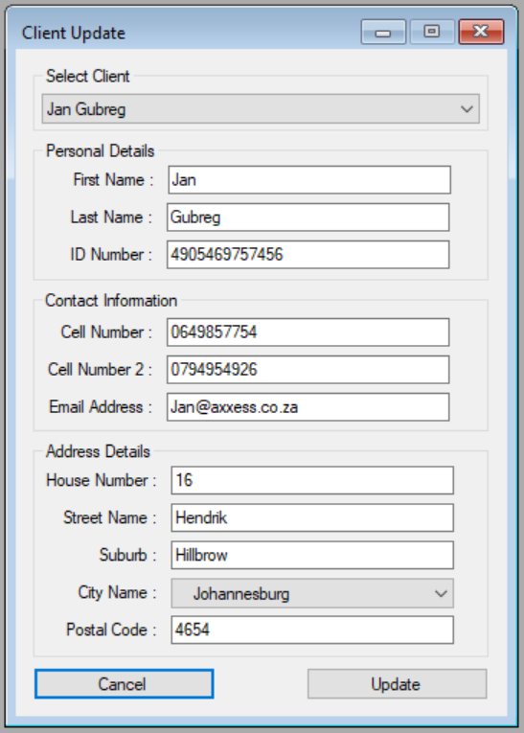

**Figure 4. Client Update Form**

* + 1. **Add Employee Form**

The Add Employee Form (Figure 5) is used to add new employees to systems database. There are 12 input fields concerning the employee information.

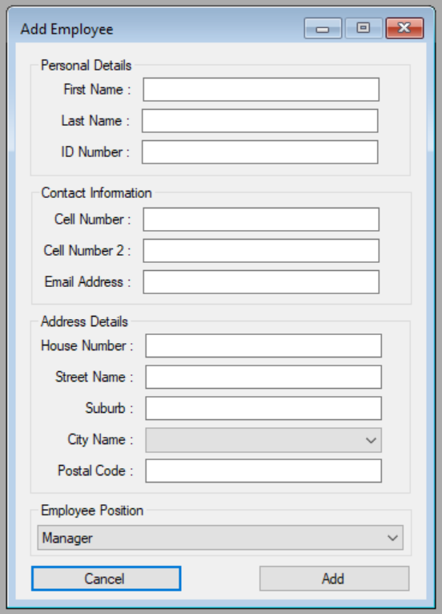

**Figure 5. Add Employee Form**

* + 1. **Update Employee Form**

The Update Employee Form (Figure 6) is used to update existing information in employees on systems database.

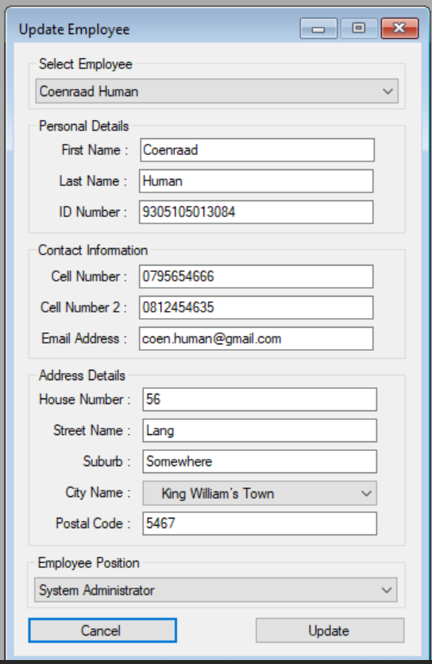

**Figure 6. Update Employee Form**

* + 1. 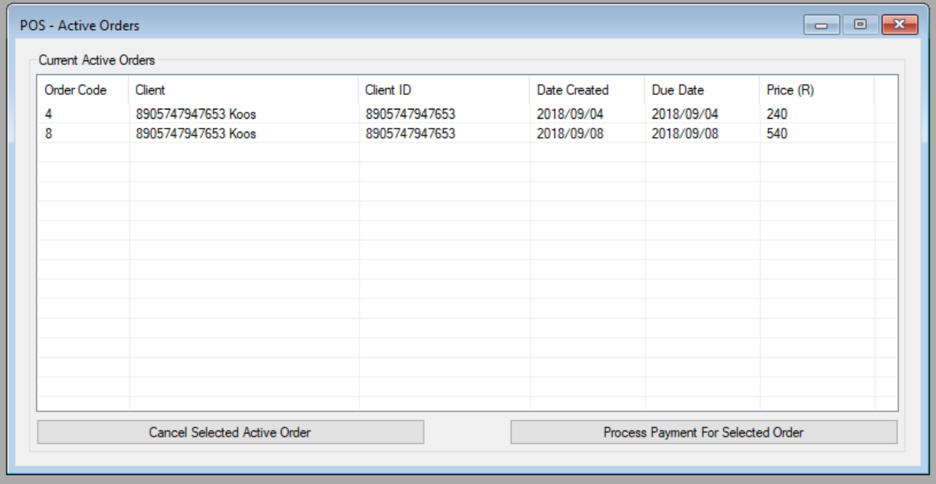**Active Orders Window**

**Figure 7. Active Order Window**

The Active Order Window (Figure 7) is used to display all active orders which haven’t been payed and still need to be processed or cancelled if the users should have to.

* + 1. **Past Orders Window**

The Past Order Window (Figure 8) displays all orders already processed on a specific date as well as the client, client ID and price for that specific order.

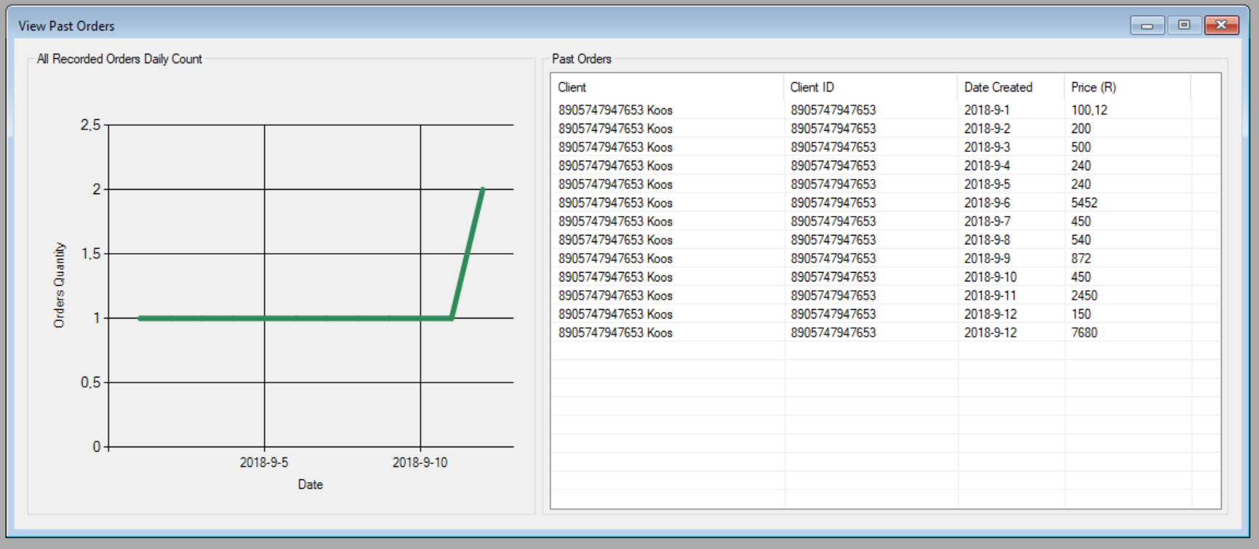

**Figure 8. Past Order Window**

* + 1. **Place Orders Form**

The Place Orders Form (Figure 9) has 4 input fields and is used to select a product from the database with all existing products to add to a client cart. The date, time and client also needs to be selected to ‘Place Order’.

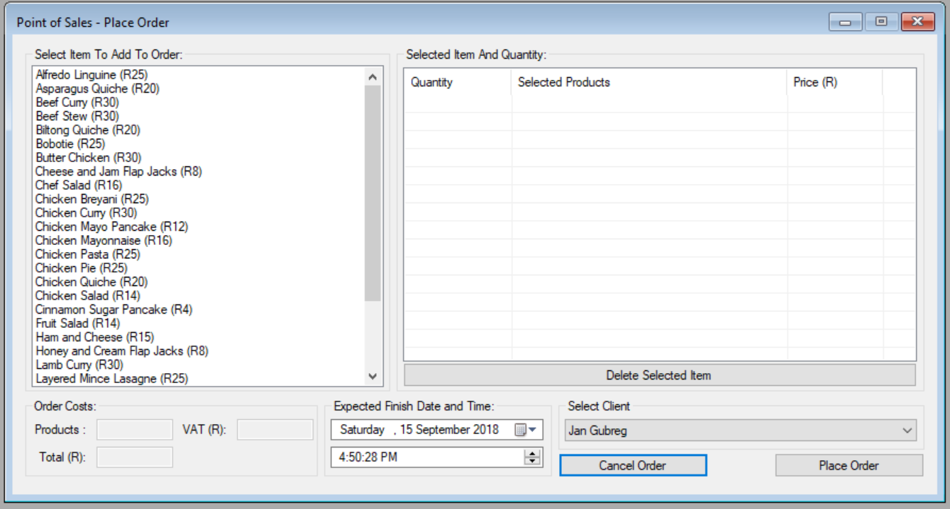

**Figure 9. Place Order Form**

* + 1. **Sales Report Window**

The Sales Report Window (Figure 10) is used to display sales for a specified month depending on orders processed

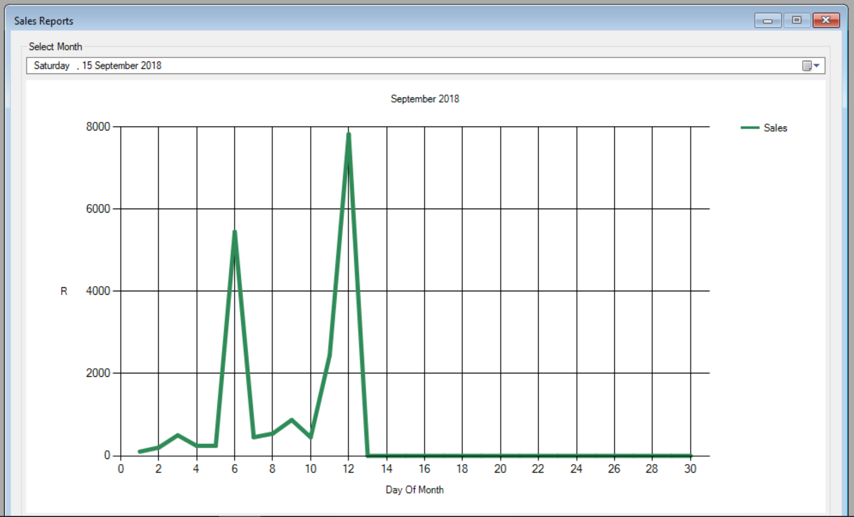

**Figure 10. Sales Report Window**

* + 1. **User Maintenance Form**

The User Maintenance Form (Figure 11) consists out of 9 input fields used to update the level of access certain users of the system have as well as completely removing a user or adding one.

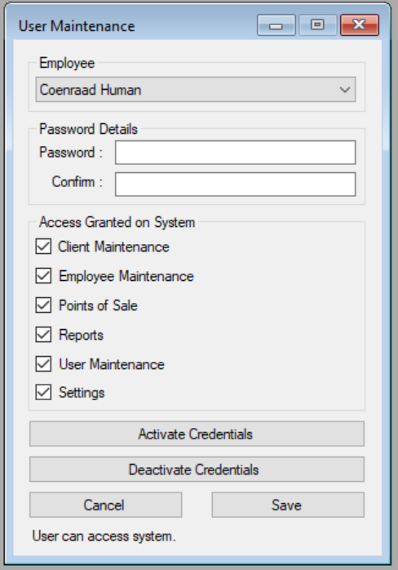

**Figure 11. User Maintenance Form**